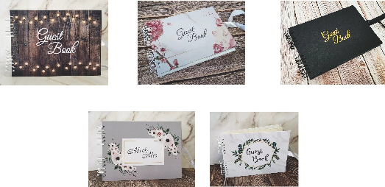­­­

Mr & Mrs

Marble

(with Gold & Green wreath

Black

Floral

Rustic

**Client Information**

Name:

Contact Number:

Email Address:

**Event Information**

Date:

Venue Address:

Function Type:

Start time: Finish Time:

Number of Guests:

Age Range:

Name to be displayed on prints:

(i.e Mr & Mrs Smith, Newlyweds, Daniel & Tara etc..)

Additional Comments:

(Access information)

**Guest book preference**

Please tick the guest book you would like for your event.



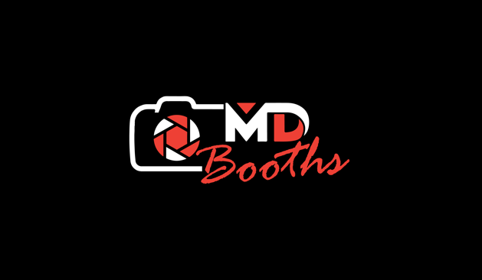

Our Package

3 Hour Hire package

from £425

Unlimited Booth Visits

Instant prints

Custom print designs

Interactive signing & animations

Great selection of props

Photo booth host

Guest book

On glass games

GIFs / Videos

Direct MMS / Email Copies

Additional operations hours £125

Idol hours £80